Section I: Scenario Demographics

Scenario Title: | CCB OD
Date of Development: | 24/05/2015 (DD/MM/YYYY)
Target Learning Group: | Juniors (PGY 1 – 2) Seniors (PGY ≥ 3) All Groups

Section II: Scenario Developers

Scenario Developer(s): | Kyla Caners
Affiliations/Institution(s): | McMaster University
Contact E-mail (optional): | kcaners@gmail.com

Section III: Curriculum Integration

Learning Goals & Objectives
Educational Goal: | To expose learners to a multi-drug overdose and the management of a severe CCB OD.
CRM Objectives: | - Maintain calm leadership throughout complex case.  - Demonstrate situational awareness as patient status changes
Medical Objectives: | - Recognize a possible CCB overdose  - Administer appropriate early treatments for a CCB overdose  - Recognize hypercapneic respiratory failure and manage appropriately.  - Consider intralipid as treatment in an arrested CCB overdose

Case Summary: Brief Summary of Case Progression and Major Events
A 48-year-old female presents with a possible multi-drug overdose including glyburide, clonazepam and nifedipine. She will remain hypotensive throughout the case, despite treatment with calcium, high dose insulin, and other vasopressors. She will also have progressive respiratory depression and will eventually require intubation. She will then proceed to arrest. The team will be expected to give intralipid once the patient has arrested.

References
Marx, J. A., Hockberger, R. S., Walls, R. M., & Adams, J. (2013). Rosen's emergency medicine: Concepts and clinical practice. St. Louis: Mosby.

Section IV: Scenario Script

A. Scenario Cast & Realism
Patient: | Computerized Mannequin |  |  |  |  | Realism:  Select most important dimension(s) |  |  | Conceptual
 | Mannequin |  |  |  |  |  |  |  | Physical
 | Standardized Patient |  |  |  |  |  |  |  | Emotional/Experiential
 | Hybrid |  |  |  |  |  |  |  | Other:
 | Task Trainer |  |  |  |  |  |  |  | N/A
Confederates | Brief Description of Role
Family member | Brings list of medications, describes patient’s mood.
B. Required Monitors
EKG Leads/Wires |  |  | Temperature Probe |  |  |  | Central Venous Line
NIBP Cuff |  |  | Defibrillator Pads |  |  |  | Capnography
Pulse Oximeter |  |  | Arterial Line |  |  |  | Other:
C. Required Equipment
Gloves |  |  | Nasal Prongs |  |  |  | Scalpel
Stethoscope |  |  | Venturi Mask |  |  |  | Tube Thoracostomy Kit
Defibrillator |  |  | Non-Rebreather Mask |  |  |  | Cricothyroidotomy Kit
IV Bags/Lines |  |  | Bag Valve Mask |  |  |  | Thoracotomy Kit
IV Push Medications |  |  | Laryngoscope |  |  |  | Central Line Kit
PO Tabs |  |  | Video Assisted Laryngoscope |  |  |  | Arterial Line Kit
Blood Products |  |  | ET Tubes |  |  |  | Other: intralipid
Intraosseous Set-up |  |  | LMA |  |  |  | Other:
D. Moulage
None required. Could put emesis on shirt if desired.

E. Approximate Timing
Set-Up: |  | 3 min |  | Scenario: | 12 min |  |  | Debriefing: |  | 15 min

Section V: Patient Data and Baseline State

A. Clinical Vignette: To Read Aloud at Beginning of Case
A 48-year-old female presents to the ED with an unknown overdose. She was out drinking with friends until an hour ago. Her daughter came home and found her with vomit around her, empty pill bottles, and bits of pills in her vomit.
B. Patient Profile and History
Patient Name: Yvette Clark |  |  |  |  |  | Age: 48 |  |  |  |  |  |  |  | Weight: 100kg
Gender: M F |  |  |  |  |  | Code Status: Full
Chief Complaint: ?OD
History of Presenting Illness: Out drinking last night. May have overdosed on meds when got home.
Past Medical History: |  | HTN |  |  |  |  | Medications: |  |  |  |  | Nifedipine XR 60mg daily
 |  | DM |  |  |  |  |  |  |  |  |  | Glyburide 5mg daily
 |  | Depression |  |  |  |  |  |  |  |  |  | Lasix 40mg daily
 |  |  |  |  |  |  |  |  |  |  |  | HCTZ 25mg daily
 |  |  |  |  |  |  |  |  |  |  |  | Clonazepam 2mg qHS
Allergies: None
Social History: Single mother of two children, now grown. (Daughter here in ED.) Drinks heavily on weekends.
Review of Systems: |  | CNS: |  |  | Nil
 |  | HEENT: |  |  | Nil
 |  | CVS: |  |  | Nil.
 |  | RESP: |  |  | Nil
 |  | GI: |  |  | Emesis prior to arrival
 |  | GU: |  |  | Nil
 |  | MSK: |  |  | Nil |  |  |  |  |  |  |  | INT: |  | Nil
C. Baseline Simulator State and Physical Exam
No Monitor Display |  |  |  | Monitor On, no data displayed |  |  |  |  |  |  | Monitor on Standard Display
HR: 50/min |  |  | BP: 87/43 |  |  |  |  | RR: 10/min |  |  |  |  |  |  | O₂SAT: 95% RA
Rhythm: junctional |  |  | T: 36ºC |  |  |  |  | Glucose: 6.8 mmol/L |  |  |  |  |  |  | GCS: 9 (E2 V2 M5)
General Status: Somnolent, looks unwell.
CNS: | Somnolent. Grunts/moans only. Opens eyes to pain, localizes to pain.
HEENT: | No signs HI. Pupils 3mm, reactive.
CVS: | No murmur.
RESP: | Slow resp rate. Slight work of breathing.
ABDO: | Soft, NT.
GU: | Nil.
MSK: | No signs trauma. |  |  |  |  |  |  |  | SKIN: | Nil.

Scenario States, Modifiers and Triggers
Patient State | Patient Status | Learner Actions, Modifiers & Triggers to Move to Next State
1. Baseline State  Rhythm: sinus brady with 1st degree block  HR: 50/min  BP: 87/43  RR: 10/min  O₂SAT: 95% RA  T: 36ºC | Somnolent, responding to pain only. | Learner Actions  - IV, O2, monitors  - IV NS 1L bolus  - Tox bloodwork, VBG  - ECG  - Go through med list  - More history/px exam  - Check glucose (6.8)  - Trial narcan  - Call poison centre | Modifiers  Changes to patient condition based on learner action  - Narcan no effect  - 1L bolus BP 92/50 transiently  - Glucagon given emesis  Triggers  For progression to next state  - 3 min 2. Persistent Hypotension
2. Persistent Hypotension  BP 75/45 | Patient status unchanged | Learner Actions  - Ca gluconate 2g iv bolus, consider Ca infusion 2-3g/hr  - Insulin infusion (1u/kg/hr with 0.5u/kg bolus) with D10NS @ 150ml/hr  - Check glucose q15 min  - Repeat NS bolus  - Add vasopressor infusion | Modifiers  - Post calcium BP 83/46  Triggers  - All 3 agents started 3. More Somnolent  - 9 min 3. More Somnolent
3. More Somnolent  RR 6  O₂SAT 91% | Begin state with RN saying “she seems to be making less respiratory effort” | Learner Actions  - Check glucose (7.1)  - Trial narcan (if not before)  - Assist breathing (bagging)  - Prepare for intubation | Modifiers  - Narcan No effect  Triggers  - Intubation 4. Intubation  - If don’t intubate give VBG. At 12 min 5. Arrest
4. Intubation  With pre-oxygenation:  O₂SAT 95%  Post paralytic:  RR 0 |  | Learner Actions  - Appropriate RSI  - Post-intubation CXR  - Sedation infusion  - Prepare for central line  - OG placement  - Call ICU | Modifiers  - Propofol for intubation BP 50/22  Triggers  - Intubated 5. Arrest
5. Arrest  Rhythm: asystole  No vitals | Patient pulseless. | Learner Actions  - High quality CPR  - EtCO2 monitoring  - Epinephrine q3 min  - Calcium Chloride & HCO3  - Consider intralipid | Modifiers  Triggers  - Intralipid given END CASE  - 15 min END CASE
Section VI: Scenario Progression

Section VII: Supporting Documents, Laboratory Results, & Multimedia

Laboratory Results
VBG | pH: 6.97 | PCO₂: 106 | PO₂: 50 | HCO₃: 7

Images (ECGs, CXRs, etc.)
Initial ECG: Sinus brady with 1st degree block
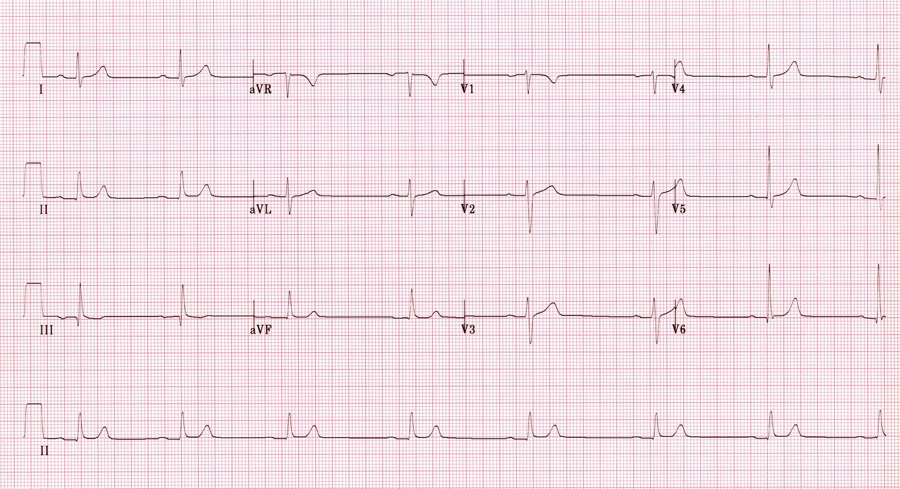
ECG source: http://lifeinthefastlane.com/ecg-library/beta-blocker-and-calcium-channel-blocker-toxicity/sb-1hb/
Post-Intubation CXR:
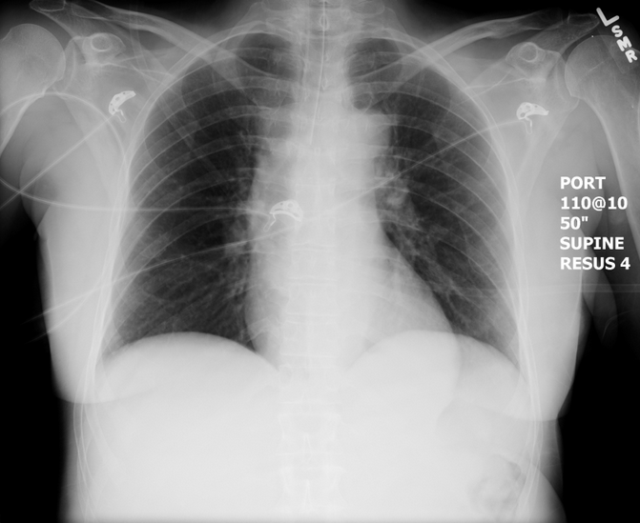
CXR source: https://emcow.files.wordpress.com/2012/11/normal-intubation2.jpg

Section VIII: Debriefing Guide

General Debriefing Plan
Individual | Group |  | With Video | Without Video
Objectives
Educational Goal: |  | To expose learners to a multi-drug overdose and the management of a severe CCB OD.
CRM Objectives: |  | - Maintain calm leadership throughout complex case.  - Demonstrate situational awareness as patient status changes
Medical Objectives: |  | - Recognize a possible CCB overdose  - Administer appropriate early treatments for a CCB overdose  - Recognize hypercapneic respiratory failure and manage appropriately.  - Consider intralipid as treatment in an arrested CCB overdose
Sample Questions for Debriefing
- When did you first consider nifedipine to be a possible cause of hypotension?
- When did you first consider intubation?
- What are the first line treatments for a CCB overdose?
- When is intralipid indicated in a CCB overdose?
- Why do you think the patient became somnolent?
Key Moments
Recognition of hypotension as possibly due to CCB
Recognition of respiratory depression and need for intubation
Recognition of need for intralipid in context of cardiac arrest

